Module-1
231fa04919@gmail.com
Exercise 1: Implementing the Singleton Pattern
Source code:
using System;
class Singleton
{
private static Singleton instance;
private Singleton()
{
Console.WriteLine("Singleton Instance Created");
}
public static Singleton GetInstance()
{
if (instance == null)
{
instance = new Singleton();
}
return instance;
}
public void DisplayMessage()
{
Console.WriteLine("Hello from Singleton Pattern!");
}
}
class Program
{
static void Main(string[] args)
{
Singleton s1 = Singleton.GetInstance();
Singleton s2 = Singleton.GetInstance();
s1.DisplayMessage()
if (s1 == s2)
{
Console.WriteLine("Both objects are the same instance.");
}
else
{
Console.WriteLine("Different instances created.");
}
}
}
Output:
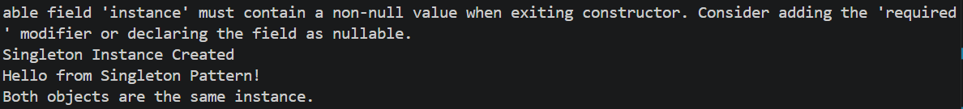

Exercise 2: Implementing the Factory Method Pattern

Source code:
using System;
interface IShape
{
void Draw();
}
class Circle : IShape
{
public void Draw()
{
Console.WriteLine("Drawing Circle");
}
}
class Rectangle : IShape
{
public void Draw()
{
Console.WriteLine("Drawing Rectangle");
}
}
class ShapeFactory
{
public static IShape GetShape(string shapeType)
{
if (shapeType.ToLower() == "circle")
return new Circle();
if (shapeType.ToLower() == "rectangle")
return new Rectangle();
return null;
}
}
class Program
{
static void Main(string[] args)
{
IShape shape1 = ShapeFactory.GetShape("circle");
shape1.Draw();
IShape shape2 = ShapeFactory.GetShape("rectangle");
shape2.Draw();
}
}
Output:
